**DBMS Project - 2**

**Topic: - Hospital**

**Submission Date: - 12 Feb’ 2018**

**Submission To: - T. Ramakrishnudu**

**Submitted By : -**

**Divas Jindal (177117)**

**Meet Shah Mehta (177135)**

**Tables:-**

**INTERN**

|  |  |  |
| --- | --- | --- |
| **Attribute** | **Datatype** | **Constraints and Characteristics** |
| E_ID | NUMERIC | Primary Key, Foreign Key |
| DEPT | VARCHAR(20) | NOT NULL |
| SUPERVISOR_ID | NUMERIC | FOREIGN KEY, NOT NULL |
| POST | VARCHAR(10) | NOT NULL |
| COLLEGE/INSTITUTION | VARCHAR(50) | NOT NULL |
| DoJ | DATE | NOT NULL |

**NON-TECHNICAL STAFF**

|  |  |  |
| --- | --- | --- |
| **Attribute** | **Datatype** | **Constraints and Characteristics** |
| E_ID | NUMERIC | PRIMARY KEY, FOREIGN KEY |
| DEPT | VARCHAR(20) | NOT NULL |
| SUPERVISOR_ID | NUMERIC | FOREIGN KEY, NOT NULL |
| POST | VARCHAR(10) | NOT NULL |

**BRANCH**

|  |  |  |
| --- | --- | --- |
| **Attribute** | **Datatype** | **Constraints and Characteristics** |
| B_ID | NUMERIC | PRIMARY KEY |
| NAME | VARCHAR(20) | NOT NULL |
| ADDRESS | VARCHAR(50) | NOT NULL |
| DATE_OF_EST | DATE | NOT NULL |

**SALARY**

|  |  |  |
| --- | --- | --- |
| **Attribute** | **Datatype** | **Constraints and Characteristics** |
| E_ID | NUMERIC | PRIMARY KEY, FOREIGN KEY |
| BASE | NUMERIC | NOT NULL |
| HRA | NUMERIC | NOT NULL |
| PF | NUMERIC | NOT NULL |
| TOTAL | NUMERIC | NOT NULL |

**PATIENTS**

|  |  |  |
| --- | --- | --- |
| **Attribute** | **Datatype** | **Constraints and Characteristics** |
| P_ID | NUMERIC | PRIMARY KEY |
| NAME | VARCHAR(20) | NOT NULL |
| SEX | VARCHAR(1) | NOT NULL |
| ADDRESS | VARCHAR(50) | NOT NULL |
| AGE | NUMERIC | NOT NULL |
| DEPT | VARCHAR(20) | NOT NULL |
| DISEASE | VARCHAR(50) | NOT NULL |
| D_o_RELEASE | DATE |  |
| D_o_ADMISSION | DATE | NOT NULL |
| BILL_ID | NUMERIC | FOREIGN KEY |
| STATUS | VARCHAR(10) | NOT NULL |

**REFER**

|  |  |  |
| --- | --- | --- |
| **Attribute** | **Datatype** | **Constraints and Characteristics** |
| P_ID | NUMERIC | PRIMARY KEY(1), FOREIGN KEY |
| E_ID | NUMERIC | PRIMARY KEY(2), FOREIGN KEY |

**EMPLOYEE**

|  |  |  |
| --- | --- | --- |
| **Attribute** | **Datatype** | **Constraints and Characteristics** |
| E_ID | NUMERIC | PRIMARY KEY |
| NAME | VARCHAR(20) | NOT NULL |
| ADDRESS | VARCHAR(50) | NOT NULL |
| PROFESSION | VARCHAR(20) | NOT NULL |
| PNO | NUMERIC | NOT NULL |
| D_o_B | DATE | NOT NULL |
| D_o_J | DATE | NOT NULL |
| B_ID | NUMERIC | FOREIGN KEY |

**DOCTORS**

|  |  |  |
| --- | --- | --- |
| **Attribute** | **Datatype** | **Constraints and Characteristics** |
| E_ID | NUMERIC | PRIMARY KEY, FOREIGN KEY |
| DEPT | VARCHAR(30) | NOT NULL |
| POST | VARCHAR(30) | NOT NULL |

**NURSE**

|  |  |  |
| --- | --- | --- |
| **Attribute** | **Datatype** | **Constraints and Characteristics** |
| E_ID | NUMERIC | PRIMARY KEY, FOREIGN KEY |
| DEPT | VARCHAR(20) | NOT NULL |
| POST | VARCHAR(30) | NOT NULL |
| SUP_ID | NUMERIC | FOREIGN KEY |

**BILLS**

|  |  |  |
| --- | --- | --- |
| **Attribute** | **Datatype** | **Constraints and Characteristics** |
| BILL_ID | NUMERIC | PRIMARY KEY |
| FEE | NUMERIC | NOT NULL |
| T_COST | NUMERIC | NOT NULL |
| D_o_T | DATE | NOT NULL |
| LAB_ID | NUMERIC | FOREIGN KEY |
| TEST_NAME | VARCHAR(20) | FOREIGN KEY |

**PATIENT-BILL RELATION**

|  |  |  |
| --- | --- | --- |
| **Attribute** | **Datatype** | **Constraints and Characteristics** |
| BILL_ID | NUMERIC | PRIMARY KEY(1), FOREIGN KEY |
| P_ID | NUMERIC | PRIMARY KEY(2), FOREIGN KEY |

**TEST**

|  |  |  |
| --- | --- | --- |
| **Attribute** | **Datatype** | **Constraints and Characteristics** |
| LAB_ID | NUMERIC | PRIMARY KEY(1), FOREIGN KEY |
| TEST_NAME | VARCHAR(20) | PRIMARY KEY(2) |
| COST | NUMERIC | NOT NULL |

**LAB**

|  |  |  |
| --- | --- | --- |
| **Attribute** | **Datatype** | **Constraints and Characteristics** |
| LAB_ID | NUMERIC | PRIMARY KEY |
| DEPT | VARCHAR(20) | NOT NULL |

**RESEARCH**

|  |  |  |
| --- | --- | --- |
| **Attribute** | **Datatype** | **Constraints and Characteristics** |
| LAB_ID | NUMERIC | PRIMARY KEY(1), FOREIGN KEY |
| FIELD | VARCHAR(20) | NOT NULL |
| TOPIC | VARCHAR(20) | NOT NULL |
| ALLOWANCE | NUMERIC | NOT NULL |
| E_ID | NUMERIC | PRIMARY KEY(2), FOREIGN KEY |
| DURATION | NUMERIC | NOT NULL |

**\*FUNCTIONAL DEPENDENCIES AND PRIMARY KEY**

**1)INTERN :-**

* E_ID -> {DEPT, SUPERVISOR_ID, POST, DoJ}

Since all fields depend on E_ID, (E_ID)+ -> R. Hence, E_ID is the primary key.

**2)NON - TECHNICAL STAFF :-**

* E_ID -> {DEPT, SUPERVISOR_ID, POST}

Since all fields depend on E_ID, (E_ID)+ -> R. Hence, E_ID is the primary key.

**3)BRANCH :-**

* B_ID -> {NAME, ADDRESS, DATE_OF_EST}
* ADDRESS -> NAME

Since all fields depend on B_ID, (B_ID)+ -> R. Hence, B_ID is the primary key.

**4)SALARY :-**

* E_ID -> {BASE, HRF, PF, TOTAL}
* {BASE, HRF, PF} -> TOTAL

Since all fields depend on E_ID, (E_ID)+ -> R. Hence, E_ID is the primary key.

**5)PATIENTS :-**

* P_ID -> {NAME, AGE, ADDRESS, DISEASE, DEPT, D_o_ADMISSION, D_o_RELEASE, BILL_ID, STATUS}
* {NAME, AGE, ADDRESS, AGE} -> DISEASE
* DISEASE -> DEPT

Since all fields depend on P_ID, (P_ID)+ -> R. Hence, P_ID is the primary key.

**6)REFER**

**7)EMPLOYEE:-**

* EID -> { NAME, ADDRESS, PNO, B_ID,PROFESSION, D_o_J, D_o_B}

Since all fields depend on E_ID, (E_ID)+->R. Hence, E_ID is the primary key.

**8)DOCTORS:-**

* E_ID -> { DEPT, POST}

Since all the fields depend on E_ID, (E_ID)+ ->R. Hence, E_ID is the primary key.

**9)NURSE:-**

* E_ID -> {DEPT, SUP_ID, POST}

Since all the fields depend on E_ID, (E_ID)+ ->R. Hence, E_ID is the primary key.

**10)BILLS:-**

* BILL_ID -> {FEE, T_COST, D_o_T, LAB_ID, TEST_NAME}
* {FEE, LAB_ID, TEST_NAME} -> T_COST

Since all the fields depend on BILL_ID, (BILL_ID)+ ->R. Hence, BILL_ID is the primary key.

**11)PATIENT-BILL RELATION**

**12)TEST:-**

* {LAB_ID, TEST_NAME} -> {COST}

Since all the fields depend on{LAB_ID, TEST_NAME}, {LAB_ID, TEST_NAME}+ ->R. Hence, {LAB_ID, TEST_NAME}is the primary key.

**13)LAB:-**

* {LAB_ID} -> DEPT

Since all the fields depend on LAB_ID, LAB_ID+ ->R. Hence, LAB_IDis the primary key.

**14)RESEARCH:-**

* {LAB_ID, E_ID} -> {FIELD, TOPIC, ALLOWANCE, DURATION}
* TOPIC -> FIELD

Since all the fields depend on{LAB_ID, E_ID}, {LAB_ID, E_ID}+ ->R. Hence, {LAB_ID, E_ID}is the primary key.

**\*Normalisation:-**

**1)INTERN :-**

Primary Key :- E_ID

All attributes depend on the E_ID, hence the table is 2NF.

All attributes depend directly on E_ID, hence the table is in 3NF.

All determinants(E_ID) are candidate keys, hence the table is in BCNF.

There are no multi-valued attributes, so the table is also in 4NF.

**2)NON-TECHNICAL STAFF :-**

Primary Key :- E_ID

All attributes depend on the E_ID, hence the table is 2NF.

All attributes depend directly on E_ID, hence the table is in 3NF.

All determinants(E_ID) are candidate keys, hence the table is in BCNF.

There are no multi-valued attributes, so the table is also in 4NF.

**3)BRANCH :-**

Primary Key :- B_ID

All attributes depend on the E_ID, hence the table is 2NF.

All attributes depend directly on E_ID, hence the table is in 3NF.

All determinants(E_ID, ADDRESS) are candidate keys, hence the table is in BCNF.

There are no multi-valued attributes, so the table is also in 4NF.

**4)SALARY :-**

Primary Key :- E_ID

All attributes depend on the E_ID, hence the table is 2NF.

All attributes depend directly on E_ID, hence the table is in 3NF.

All determinants are not candidate keys, hence the table is not in BCNF.

So, table is in 3NF.

**5)PATIENTS :-**

Primary Key :- P_ID

All attributes depend on the P_ID, hence the table is 2NF.

All attributes depend directly on P_ID, hence the table is in 3NF.

All determinants are not candidate keys, hence the table is not in BCNF.

So, table is in 3NF.

**6) REFER :-**

Primary Key :- {P_ID, E_ID}

Primary Key :- B_ID

All attributes depend on the E_ID, hence the table is 2NF.

All attributes depend directly on E_ID, hence the table is in 3NF.

All determinants(E_ID, ADDRESS) are candidate keys, hence the table is in BCNF.

There are no multi-valued attributes, so the table is also in 4NF.

**7)EMPLOYEE:-**

Primary Key :- E_ID

All attributes depend on the E_ID, hence the table is 2NF.

All attributes depend directly on E_ID, hence the table is in 3NF.

All determinants(E_ID) are candidate keys, hence the table is in BCNF.

There are no multi-valued attributes, so the table is also in 4NF.

**8)DOCTORS:-**

Primary Key :- E_ID

All attributes depend on the E_ID, hence the table is 2NF.

All attributes depend directly on E_ID, hence the table is in 3NF.

All determinants(E_ID) are candidate keys, hence the table is in BCNF.

There are no multi-valued attributes, so the table is also in 4NF.

**9)NURSE:-**

Primary Key :- E_ID

All attributes depend on the E_ID, hence the table is 2NF.

All attributes depend directly on E_ID, hence the table is in 3NF.

All determinants(E_ID) are candidate keys, hence the table is in BCNF.

There are no multi-valued attributes, so the table is also in 4NF.

**10)BILLS:-**

Primary Key :- BILL_ID

All attributes depend on the BILL_ID, hence the table is 2NF.

All attributes depend directly on BILL_ID, hence the table is in 3NF.

All determinants(BILL_ID) are candidate keys, hence the table is in BCNF.

There are no multi-valued attributes, so the table is also in 4NF.

**11)PATIENT-BILL RELATION:-**

Primary Key :- {BILL_ID, P_ID}

All attributes depend on the BILL_ID, hence the table is 2NF.

All attributes depend directly on BILL_ID, hence the table is in 3NF.

There are no multi-valued attributes, so the table is also in 4NF.

**12)TEST:-**

Primary Key :- {LAB_ID,TEST_NAME}

All attributes depend on the LAB_ID, hence the table is 2NF.

There are no multi-valued attributes, so the table is also in 4NF.

**13)LAB:-**

Primary Key :- LAB_ID

All attributes depend on the LAB_ID, hence the table is 2NF.

All attributes depend directly on LAB_ID, hence the table is in 3NF.

All determinants(LAB_ID) are candidate keys, hence the table is in BCNF.

There are no multi-valued attributes, so the table is also in 4NF.

**14)RESEARCH:-**

Primary Key :- LAB_ID,E_ID

All attributes depend on the E_ID, hence the table is 2NF.

All determinants(E_ID) are candidate keys, hence the table is in BCNF.

There are no multi-valued attributes, so the table is also in 4NF.

**Entity-Relationship Diagram:-**

**Diagram on next page.

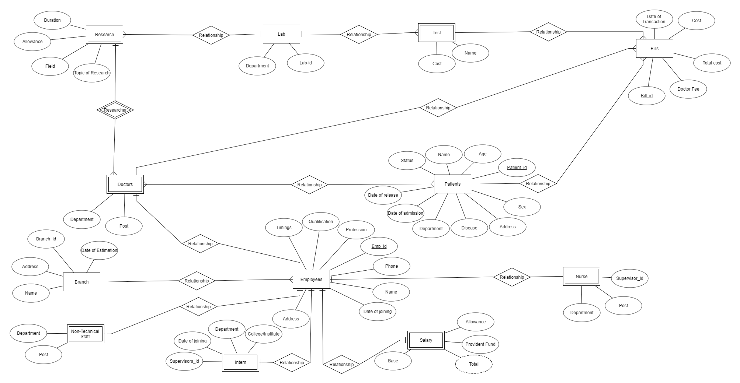

**Since ER diagram is not much visible, a separate image of ER diagram has also been mailed.

_________________________________________________________________________

_________________________________________________________________________